What species is my hamster?
There are FIVE species of hamster regularly kept as pets in the UK.
Roborovski Hamster
Although most Roborovskis are the colour of those shown in the picture below, they are now available in “Husky”:- white faced & “Pied”:- brown/grey & white patches.
Chinese Hamster
Available in 3 colours:-“Normal”:- plain brown. “White”, and “Dominant Spotted”:-white & brown patched, as picture below shows.

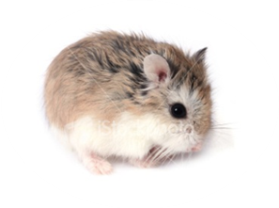
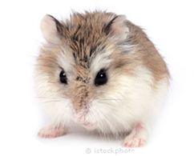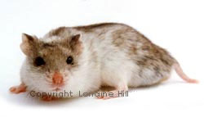

Syrian Hamster

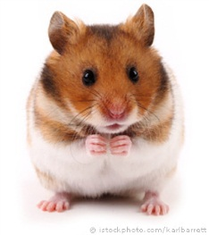
Syrian Hamsters are available in Long & Short Haired varieties, plus Satin & Rex Coated.
Syrian Hamsters are available in multitude of colours & Patterns, including:- Cream, Yellow, Golden, Black, White, Sable, Mink, Dark Grey, Lilac, Silver Grey, Melanistic Yellow, Tortoiseshell…etc etc

Russian Dwarf Winter White
(sometimes referred to as Siberians)
Winter Whites are available in 3 colours:- “Pearl”:- white, with black eyes (as pictured below). “Normal”:- shades of black and grey, ( as pictured below). And “Sapphire”:- a Smokey blue grey colour.

Russian Dwarf Campbell
The more common of the 2 Russian species.
Available in a multitude of colours and patterns, including:- “Argente”:- Orangey brown, with grey undercoat & red eyes. “Albino”:- white with red eyes.

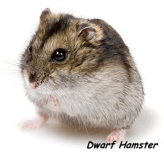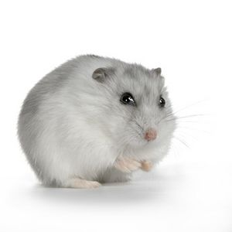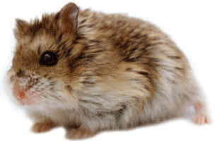

Please note that Campbell’s and Winter Whites can cross-species breed, resulting in “Hybrids”, therefore, some hamsters sold as “Russians” may be a cross-bred species. Some Hybrids can suffer from health issues; therefore we recommend you do NOT cross species breed. ©WLDB 2014

